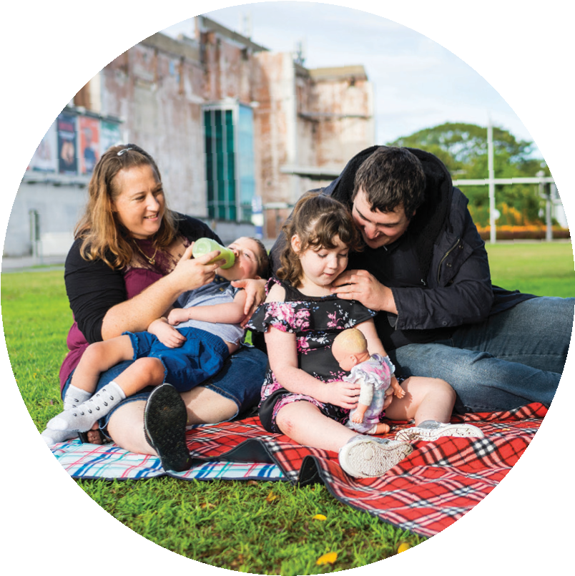
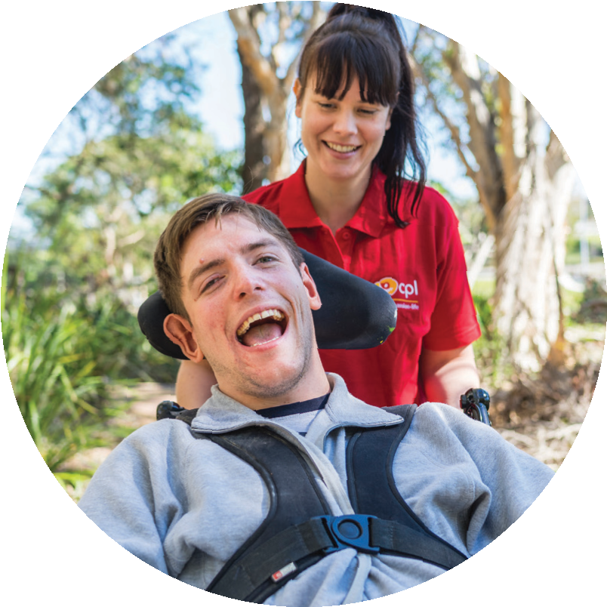

Preparing for your planning meeting with the NDIA

Thank you for continuing to choose CPL - Choice, Passion, Life as your NDIS provider.
For nearly 70 years we’ve been helping people grow beyond expectations, seize new opportunities and do amazing things with their lives.
The stories from that journey have taught us that every moment, interaction and relationship is an opportunity to question, evolve and challenge ourselves and others to go beyond good enough. CPL can support you to be fully prepared for your plan meeting with the NDIA.
This workbook will help you to understand your current supports and identify additional supports or unmet needs.
It will also help you to identify your goals for your first plan and the supports you will need to work towards those goals.
The workbook is designed so that you can work with us to fill it in at a face to face meeting. Or, you can choose to fill it in yourself at home.
We can also review your equipment and allied health needs for the year ahead and provide you with an assessment to take to your plan meeting.

CONTENTS

1.0 My Accommodation..……………………………….1

2.0 Client Profile………….…………………………………3

3.0 My Current Supports..………………………………5

4.0 My Goals…..……………………………………………..13

5.0 My Future Supports…..………………………….…17

6.0 Final things to consider..……….……………..….28

1. My Accommodation

My current accommodation - Supported Independent Living (SIL)
The number of other people I live with: | Click or tap here to enter text.
Is this Specialist Disability  Accommodation (SDA)? | ☐ Yes ☐ No ☐ Not sure
I am happy with my current home and wish to continue living there at this time | ☐ Yes ☐ No ☐ Not sure
I am thinking about a change and would like assistance to explore other housing options | ☐ Yes ☐ No ☐ Not sure

OR

My current accommodation - independent living
The number of other people I live with: | Click or tap here to enter text.
I am happy with my current home and wish to continue living there at this time | ☐ Yes ☐ No ☐ Not sure
I am thinking about a change and would like assistance to explore other housing options | ☐ Yes ☐ No ☐ Not sure

OR

My current accommodation – family home
The number of other people I live with: | Click or tap here to enter text.
I am happy with my current home and wish to continue living there at this time | ☐ Yes ☐ No ☐ Not sure
I am thinking about a change and would like assistance to explore other housing options | ☐ Yes ☐ No ☐ Not sure

My support needs are best described as:
☐ Standard (staff who support me do not need additional training to support me safely)
☐ Complex (all of the staff who support me must have additional training in order to support me safely)

Justification for Complex/High Intensity Support: Click or tap here to enter text.

2. Client Profile

It’s all about me!
My background - basic details of where I was born, where I grew up, things that are very important to me and about me | Click or tap here to enter text.
My current support needs – these are the general comments about the level of support I need each day | Click or tap here to enter text.
The address where I live | Click or tap here to enter text.
Who I live with | Click or tap here to enter text.
My support arrangements for where I live | Click or tap here to enter text.
My main family contact | Click or tap here to enter text.
My current health – please comment generally | Click or tap here to enter text.
My current job or volunteer work – where I work, how many days per week, how I get there, what support I need to maintain my job | Click or tap here to enter text.
My current transport funding (Mobility Allowance) per fortnight | $Click or tap here to enter text.
My current transport costs  per week | $Click or tap here to enter text.
Risks that are of current concern to my health and wellbeing | Click or tap here to enter text.
Other things I am concerned about | Click or tap here to enter text.

3.0 My Current Supports

This is how I currently use my funded supports each week
Complete the boxes with the number of hours you are supported each day of the week and briefly describe the activity that you undertake in those hours.
 |  | Support at Home |  | Support to Access the Community |  | Support to Work or Volunteer | Support with Studying or Training | Support with Skills Building | Allied Health Supports
 |  | Day | Evening | Day | Evening
Mon | Hours | Click or tap here to enter text. | Click or tap here to enter text. | Click or tap here to enter text. | Click or tap here to enter text. | Click or tap here to enter text. | Click or tap here to enter text. | Click or tap here to enter text. | Click or tap here to enter text.
 | Activities | Click or tap here to enter text. | Click or tap here to enter text. | Click or tap here to enter text. | Click or tap here to enter text. | Click or tap here to enter text. | Click or tap here to enter text. | Click or tap here to enter text. | Click or tap here to enter text.
Tues | Hours | Click or tap here to enter text. | Click or tap here to enter text. | Click or tap here to enter text. | Click or tap here to enter text. | Click or tap here to enter text. | Click or tap here to enter text. | Click or tap here to enter text. | Click or tap here to enter text.
 | Activities | Click or tap here to enter text. | Click or tap here to enter text. | Click or tap here to enter text. | Click or tap here to enter text. | Click or tap here to enter text. | Click or tap here to enter text. | Click or tap here to enter text. | Click or tap here to enter text.
Wed | Hours | Click or tap here to enter text. | Click or tap here to enter text. | Click or tap here to enter text. | Click or tap here to enter text. | Click or tap here to enter text. | Click or tap here to enter text. | Click or tap here to enter text. | Click or tap here to enter text.
 | Activities | Click or tap here to enter text. | Click or tap here to enter text. | Click or tap here to enter text. | Click or tap here to enter text. | Click or tap here to enter text. | Click or tap here to enter text. | Click or tap here to enter text. | Click or tap here to enter text.
Thur | Hours | Click or tap here to enter text. | Click or tap here to enter text. | Click or tap here to enter text. | Click or tap here to enter text. | Click or tap here to enter text. | Click or tap here to enter text. | Click or tap here to enter text. | Click or tap here to enter text.
 | Activities | Click or tap here to enter text. | Click or tap here to enter text. | Click or tap here to enter text. | Click or tap here to enter text. | Click or tap here to enter text. | Click or tap here to enter text. | Click or tap here to enter text. | Click or tap here to enter text.
Fri | Hours | Click or tap here to enter text. | Click or tap here to enter text. | Click or tap here to enter text. | Click or tap here to enter text. | Click or tap here to enter text. | Click or tap here to enter text. | Click or tap here to enter text. | Click or tap here to enter text.
 | Activities | Click or tap here to enter text. | Click or tap here to enter text. | Click or tap here to enter text. | Click or tap here to enter text. | Click or tap here to enter text. | Click or tap here to enter text. | Click or tap here to enter text. | Click or tap here to enter text.
Sat | Hours | Click or tap here to enter text. | Click or tap here to enter text. | Click or tap here to enter text. | Click or tap here to enter text. | Click or tap here to enter text. | Click or tap here to enter text. | Click or tap here to enter text. | Click or tap here to enter text.
 | Activities | Click or tap here to enter text. | Click or tap here to enter text. | Click or tap here to enter text. | Click or tap here to enter text. | Click or tap here to enter text. | Click or tap here to enter text. | Click or tap here to enter text. | Click or tap here to enter text.
Sun | Hours | Click or tap here to enter text. | Click or tap here to enter text. | Click or tap here to enter text. | Click or tap here to enter text. | Click or tap here to enter text. | Click or tap here to enter text. | Click or tap here to enter text. | Click or tap here to enter text.
 | Activities | Click or tap here to enter text. | Click or tap here to enter text. | Click or tap here to enter text. | Click or tap here to enter text. | Click or tap here to enter text. | Click or tap here to enter text. | Click or tap here to enter text. | Click or tap here to enter text.
13
13

Other Supports in my life - extra information
Click or tap here to enter text.

3.1 My Current supports
I have family and friends who are able to provide me with some informal supports | ☐ Yes ☐ No
Briefly explain the type of informal (unpaid) support these people provide to you, and if it’s sustainable | Click or tap here to enter text.
How is this support going, is it working well or not? | Click or tap here to enter text.
People who help me make decisions | Click or tap here to enter text.
Public Guardian is appointed for decision making | ☐ Yes ☐ No
Public Trust is appointed for my finances | ☐ Yes ☐ No
People who help me to manage my money | Click or tap here to enter text.
Community groups that provide support to me (examples are schools, sporting or hobby clubs, community groups) | Click or tap here to enter text.
Disability providers who support me | Click or tap here to enter text.
Other | Click or tap here to enter text.

3.2 Medical and/or therapy services that I currently use
List all of your services including: medical, dental, specialists, physiotherapy, occupational therapy, speech pathology, social work, counselling etc.
Name | Type of service | Location | Support I need  to attend appointments | How many times per year?
Click or tap here to enter text. | Click or tap here to enter text. | Click or tap here to enter text. | Click or tap here to enter text. | Click or tap here to enter text.
Click or tap here to enter text. | Click or tap here to enter text. | Click or tap here to enter text. | Click or tap here to enter text. | Click or tap here to enter text.
Click or tap here to enter text. | Click or tap here to enter text. | Click or tap here to enter text. | Click or tap here to enter text. | Click or tap here to enter text.
Click or tap here to enter text. | Click or tap here to enter text. | Click or tap here to enter text. | Click or tap here to enter text. | Click or tap here to enter text.
Click or tap here to enter text. | Click or tap here to enter text. | Click or tap here to enter text. | Click or tap here to enter text. | Click or tap here to enter text.
Click or tap here to enter text. | Click or tap here to enter text. | Click or tap here to enter text. | Click or tap here to enter text. | Click or tap here to enter text.
Click or tap here to enter text. | Click or tap here to enter text. | Click or tap here to enter text. | Click or tap here to enter text. | Click or tap here to enter text.

3.3 Consumable supports I use in my daily life
Item | Estimated Annual Cost
Continence aids | Click or tap here to enter text.
Wipes | Click or tap here to enter text.
Gloves | Click or tap here to enter text.
Mattress protectors | Click or tap here to enter text.
Other (list here) | Click or tap here to enter text.
Click or tap here to enter text. | Click or tap here to enter text.
Click or tap here to enter text. | Click or tap here to enter text.

3.4 Capital supports I use in my daily life - Assistive Technology
Think about what you need at home and also what you need when you are in the community.
Equipment that you use at home or at work – what type of equipment will you need in your home or at work (such as an electric bed, mattress, hoist and sling, bathroom and toilet equipment, furniture etc.)?
Item required | Reason – why this is needed
Click or tap here to enter text. | Click or tap here to enter text.
Click or tap here to enter text. | Click or tap here to enter text.
Click or tap here to enter text. | Click or tap here to enter text.
Click or tap here to enter text. | Click or tap here to enter text.
Click or tap here to enter text. | Click or tap here to enter text.
Click or tap here to enter text. | Click or tap here to enter text.
Click or tap here to enter text. | Click or tap here to enter text.

Equipment you use to get around – examples are things like a new walker, wheelchair, Ankle-Foot Orthoses (AFO’s) etc.
13
Item required | Reason – why this is needed
Click or tap here to enter text. | Click or tap here to enter text.
Click or tap here to enter text. | Click or tap here to enter text.
Click or tap here to enter text. | Click or tap here to enter text.
Click or tap here to enter text. | Click or tap here to enter text.
Click or tap here to enter text. | Click or tap here to enter text.
Click or tap here to enter text. | Click or tap here to enter text.

Equipment you use to communicate – examples are things like Communication Boards, Speech Generating Device, Pragmatic Organisation Dynamic Display (PODD), computer applications etc.
Item required | Reason – why this is needed
Click or tap here to enter text. | Click or tap here to enter text.
Click or tap here to enter text. | Click or tap here to enter text.
Click or tap here to enter text. | Click or tap here to enter text.
Click or tap here to enter text. | Click or tap here to enter text.
Click or tap here to enter text. | Click or tap here to enter text.
Click or tap here to enter text. | Click or tap here to enter text.
Click or tap here to enter text. | Click or tap here to enter text.

Equipment that needs to be maintained/serviced/repaired – such as hoist or wheelchair services, new slings, electric beds, commodes etc.
List all your equipment items that require maintenance | How often each year | Cost per year
Click or tap here to enter text. | Click or tap here to enter text. | Click or tap here to enter text.
Click or tap here to enter text. | Click or tap here to enter text. | Click or tap here to enter text.
Click or tap here to enter text. | Click or tap here to enter text. | Click or tap here to enter text.
Click or tap here to enter text. | Click or tap here to enter text. | Click or tap here to enter text.
Click or tap here to enter text. | Click or tap here to enter text. | Click or tap here to enter text.
Click or tap here to enter text. | Click or tap here to enter text. | Click or tap here to enter text.
Click or tap here to enter text. | Click or tap here to enter text. | Click or tap here to enter text.

4.0 My Goals

I would like to work towards achieving these goals with my first plan
My first goal:
Click or tap here to enter text.

Supports I need to achieve this goal:
Click or tap here to enter text.

Support Worker:
Click or tap here to enter text.

Therapy:
Click or tap here to enter text.

Aids or equipment:
Click or tap here to enter text.

Skill development or training:
Click or tap here to enter text.

Transport:
Click or tap here to enter text.

My second goal:
Click or tap here to enter text.

Supports I need to achieve this goal:
Click or tap here to enter text.

Support Worker:
Click or tap here to enter text.

Therapy:
Click or tap here to enter text.

Aids or equipment:
Click or tap here to enter text.

Skill development or training:
Click or tap here to enter text.

Transport:
Click or tap here to enter text.

My third goal:
Click or tap here to enter text.

Supports I need to achieve this goal:
Click or tap here to enter text.

Support Worker:
Click or tap here to enter text.

Therapy:
Click or tap here to enter text.

Aids or equipment:
Click or tap here to enter text.

Skill development or training:
Click or tap here to enter text.

Transport:
Click or tap here to enter text.

My long term goals and aspirations:
Click or tap here to enter text.

Supports I need to achieve this goal:
Click or tap here to enter text.

Support Worker:
Click or tap here to enter text.

Therapy:
Click or tap here to enter text.

Aids or equipment:
Click or tap here to enter text.

Skill development or training:
Click or tap here to enter text.

Transport:
Click or tap here to enter text.

CPL’s pre-planning workbook

5.0 My Future Supports

Core supports I need to manage my daily life
Area | How many hours per day | How many days per week | How many weeks per year | Is this support on Saturdays? | Is this support on Sundays? | Is this support on Public Holidays? | Transport
Day service (centre group based activities) | Click or tap here to enter text. | Click or tap here to enter text. | Click or tap here to enter text. | Click or tap here to enter text. | Click or tap here to enter text. | Click or tap here to enter text. | Click or tap here to enter text.
Day service (centre based – amount of 1:1 support that is needed when in a group setting) | Click or tap here to enter text. | Click or tap here to enter text. | Click or tap here to enter text. | Click or tap here to enter text. | Click or tap here to enter text. | Click or tap here to enter text. | Click or tap here to enter text.
Community, social and recreational activities (1:1) support | Click or tap here to enter text. | Click or tap here to enter text. | Click or tap here to enter text. | Click or tap here to enter text. | Click or tap here to enter text. | Click or tap here to enter text. | Click or tap here to enter text.
Support at home (1:1) (self care activities) | Click or tap here to enter text. | Click or tap here to enter text. | Click or tap here to enter text. | Click or tap here to enter text. | Click or tap here to enter text. | Click or tap here to enter text. | Click or tap here to enter text.
Short term accommodation (respite) | Click or tap here to enter text. | Click or tap here to enter text. | Click or tap here to enter text. | Click or tap here to enter text. | Click or tap here to enter text. | Click or tap here to enter text. | Click or tap here to enter text.
House and/or yard maintenance | Click or tap here to enter text. | Click or tap here to enter text. | Click or tap here to enter text. | Click or tap here to enter text. | Click or tap here to enter text. | Click or tap here to enter text. | Click or tap here to enter text.
Other Click or tap here to enter text. | Click or tap here to enter text. | Click or tap here to enter text. | Click or tap here to enter text. | Click or tap here to enter text. | Click or tap here to enter text. | Click or tap here to enter text. | Click or tap here to enter text.
Other Click or tap here to enter text. | Click or tap here to enter text. | Click or tap here to enter text. | Click or tap here to enter text. | Click or tap here to enter text. | Click or tap here to enter text. | Click or tap here to enter text. | Click or tap here to enter text.
Other Click or tap here to enter text. | Click or tap here to enter text. | Click or tap here to enter text. | Click or tap here to enter text. | Click or tap here to enter text. | Click or tap here to enter text. | Click or tap here to enter text. | Click or tap here to enter text.
Other Click or tap here to enter text. | Click or tap here to enter text. | Click or tap here to enter text. | Click or tap here to enter text. | Click or tap here to enter text. | Click or tap here to enter text. | Click or tap here to enter text. | Click or tap here to enter text.

5.1 MY FUTURE SUPPORTS

Capacity building: Therapeutic supports that could improve my daily living
Think about your current situation and things that could improve your daily living. There are some therapy supports you may wish to consider. Do you have any specific needs such as mealtime management guidelines, manual handling support, behaviour management support, social support etc.?
Which overarching goal does this address | What is required | Reason for why this is needed | Supports needed to attend this activity | Transport required for this activity
Example: Safe mealtime participation | Mealtime management guidelines | To document how I eat my meals and how best to support me | Allied Health | Allied Health Professional will travel to my home
Click or tap here to enter text. | Click or tap here to enter text. | Click or tap here to enter text. | Click or tap here to enter text. | Click or tap here to enter text.
Click or tap here to enter text. | Click or tap here to enter text. | Click or tap here to enter text. | Click or tap here to enter text. | Click or tap here to enter text.
Click or tap here to enter text. | Click or tap here to enter text. | Click or tap here to enter text. | Click or tap here to enter text. | Click or tap here to enter text.

5.2 My future supports - capacity building (other)
These are supports that I need to enable me to do things like:

- Improve my learning
- Improve my health and wellbeing
- Improve my relationships
- Finding and Keeping a Job
- Increased Social and Community Participation
- Support Coordination
- Plan Management

Support area | Things to consider | Which goal does this address | Supports need to attend this activity | Transport needed for this activity
Positive Behaviour Support Plan | Do you already have a Positive Behaviour Support Plan in place? Will it need to be reviewed in the next 12 months?  ☐ Yes ☐ No | Click or tap here to enter text. | Click or tap here to enter text. | Click or tap here to enter text.
Behaviour support | Do you feel that you would benefit from strategies or recommendations to support positive behaviours and your emotional wellbeing?  ☐ Yes ☐ No | Click or tap here to enter text. | Click or tap here to enter text. | Click or tap here to enter text.
Assistance with medication | Do you require assistance to take medications?  ☐ Yes ☐ No | Click or tap here to enter text. | Click or tap here to enter text. | Click or tap here to enter text.
Counselling or social work | Do you need support to develop confidence and wellbeing or engage in school or the community? Do you currently engage at times with a Social Worker or counselling services?  ☐ Yes ☐ No | Click or tap here to enter text. | Click or tap here to enter text. | Click or tap here to enter text.
Increased health and wellbeing | Do you need assistance for exercise or therapies that increase your physical capacity or general wellbeing?  ☐ Yes ☐ No | Click or tap here to enter text. | Click or tap here to enter text. | Click or tap here to enter text.
Improved learning | Do you need help with the transition through school and to further education?  ☐ Yes ☐ No | Click or tap here to enter text. | Click or tap here to enter text. | Click or tap here to enter text.
Increased Social and Community  Participation | Do you need help to develop life skills to increase your independence? Is there a training program, short course, workshop, program that you wish to undertake?  ☐ Yes ☐ No | Click or tap here to enter text. | Click or tap here to enter text. | Click or tap here to enter text.
 | Do you need help with developing skills to allow you to participate in community, social and recreational activities?  ☐ Yes ☐ No | Click or tap here to enter text. | Click or tap here to enter text. | Click or tap here to enter text.
Finding and Keeping a Job | Do you need assistance with finding or keeping a job?  ☐ Yes ☐ No | Click or tap here to enter text. | Click or tap here to enter text. | Click or tap here to enter text.
 | Do you need support while working on your job? This may include training, personal care or workplace modifications.  ☐ Yes ☐ No | Click or tap here to enter text. | Click or tap here to enter text. | Click or tap here to enter text.
Coordination of Supports | Do you need help to coordinate your supports, participate in the community and develop a strong network of supports?  ☐ Yes ☐ No | Click or tap here to enter text. | Click or tap here to enter text. | Click or tap here to enter text.
Training in Plan Management | Do you need training in how to manage your plan?  ☐ Yes ☐ No | Click or tap here to enter text. | Click or tap here to enter text. | Click or tap here to enter text.

5.3 Staff training requirements
Do your support staff require additional specific training, if so, what?
Support needed | Training required
Click or tap here to enter text. | Click or tap here to enter text.
Click or tap here to enter text. | Click or tap here to enter text.
Click or tap here to enter text. | Click or tap here to enter text.
Click or tap here to enter text. | Click or tap here to enter text.
Click or tap here to enter text. | Click or tap here to enter text.
Click or tap here to enter text. | Click or tap here to enter text.

5.4 Modifications
Modifications | Why is this needed | Do you have supporting evidence?
Modifications  required for my home | Click or tap here to enter text. | ☐ Yes  ☐ No
Modifications required for my vehicle | Click or tap here to enter text. | ☐ Yes  ☐ No
Modifications required for my equipment (i.e. cushion mods, wheelchair mods etc.) | Click or tap here to enter text. | ☐ Yes  ☐ No

5.5 Employment - Choose your employment adventure!
SCHOOL LEAVERS (Yes, I want employment)
Are you leaving school this year? | Yes, I am
Are you interested in looking for a job? | Click or tap here to enter text.
Do you currently receive any employment support services (e.g. DES)? | Click or tap here to enter text.
What sort of job are you looking for? | Click or tap here to enter text.
Do you need skills development to assist you? | Click or tap here to enter text.
What sort of skills development/supports/ equipment/training/ resources do you need? | Click or tap here to enter text.
Do you think you need 1:1 on the job support? | Click or tap here to enter text.
Will you need transport to be able to get to work? | Click or tap here to enter text.
What are your concerns about getting a job? | Click or tap here to enter text.

CPL’s pre-planning workbook
SCHOOL LEAVERS (No, I do not want employment)
Are you leaving school this year? | Yes, I am
Are you interested in looking for a job? | No, I am not ready
Do you currently receive any employment support services (e.g. DES)? | Click or tap here to enter text.
Is finding a job something that you are considering for the future? | Click or tap here to enter text.
If yes, what sort of skills development/ supports/ equipment/resources do you think you would need? | Click or tap here to enter text.
Would you like to start building your future employment capacity through developing some skills now? | Click or tap here to enter text.
What are your concerns about getting a job? | Click or tap here to enter text.

VOLUNTEERING OR WORKING but wanting to explore other employment options
What is your current job/ volunteer position? | Click or tap here to enter text.
Is this supported employment? | Click or tap here to enter text.
If yes, what is your Disability Maintenance Instrument (DMI) Level? | Click or tap here to enter text.
Is this open employment? | Click or tap here to enter text.
What current supports/ equipment/resources do you use at work/volunteering? | Click or tap here to enter text.
What type of job/volunteer position would you like to do instead? | Click or tap here to enter text.
What is stopping you from making a change? | Click or tap here to enter text.
What supports/equipment/resources/skill development do you need to reach your employment goal? | Click or tap here to enter text.
Will your transport requirements change? | Click or tap here to enter text.
What are your concerns about making a change? | Click or tap here to enter text.

UNEMPLOYED CURRENTLY, but looking for an opportunity to work or volunteer
Are you unemployed but looking for a job? | Click or tap here to enter text.
Do you currently receive any employment support services (e.g. DES)? | Click or tap here to enter text.
What do you think is stopping you from finding or keeping a job? | Click or tap here to enter text.
What sort of job are you looking for? | Click or tap here to enter text.
What sort of skills development/supports/ equipment/training/ resources do you think you need to help you find and keep a job? | Click or tap here to enter text.
Do you think you need 1:1 on the job support? | Click or tap here to enter text.
Will you need transport to be able to get to work? | Click or tap here to enter text.
What are your concerns about getting a job? | Click or tap here to enter text.

WORKING/VOLUNTEERING but wanting to slow down, reduce days, make community connections
What is your current job/ volunteer position? | Click or tap here to enter text.
What current supports/ equipment/resources do you use at work/volunteering? | Click or tap here to enter text.
Are you wanting to stop work completely? | Click or tap here to enter text.
Are you wanting to reduce your days? If so, what would this be? | Click or tap here to enter text.
What would you like to do instead of working? | Click or tap here to enter text.
What sort of support would you need to begin reducing your workload? | Click or tap here to enter text.
What support would you need on your days off work? | Click or tap here to enter text.

6.0 Final things to consider

Think about what you need for a successful plan meeting.
Plan meetings generally commence approximately 2 months prior to the ‘go live’ date for NDIS in each region. Before you get the phone call from NDIA to arrange a meeting time, you may want to consider:
- Where do you want the meeting to take place (e.g. your home, NDIA office)?
- Who do you want to support you at the meeting?
- Do you want to have other people dialled in to the plan meeting with you?
- Are you willing to have your plan meeting over the phone?
- Or, is it important to you that the meeting is face to face?

Decide how you would like to manage your NDIS plan
Support Coordination
Tick the level of Support Coordination you would like to put in place to manage your plan.
☐ I don’t need any support to find and work with service providers or mainstream supports.
☐ I would like some support to link me with service providers, mainstream supports and community activities so I can achieve the goals in my NDIA plan.
☐ I need assistance to coordinate my supports, work with service providers and resolve issues.
☐ I want training in planning and plan management so that I can learn how to do this myself.
☐ I have complex care needs and require specialist assistance to find the right supports and coordinate my services.
Financial Management
Tick the level of financial management you would like to put in place to manage your plan.
☐ NDIA MANAGEMENT – I would like my NDIS funding to be managed by the NDIA. This means that service providers will invoice the NDIA directly. The NDIA will pay my service provider directly and I can monitor my funds through the NDIA website portal.
☐ SELF MANAGEMENT – I would like to manage my NDIS funding myself. This means that I will be invoiced by service providers of my choice and have to directly pay these service providers. I will claim funds back through the NDIA website portal and monitor my own spending.
☐ REGISTERED PLAN MANAGER - I would like to use a Registered Plan Management Provider to help me manage my plan and claim funds from the NDIA to pay my accounts for me from registered and unregistered providers.
☐ COMBINATION OF OPTIONS - I would like use a combination of options to manage my plan.

Notes:
Click or tap here to enter text.

This document is to help you prepare for your NDIS meeting.

CPL is ready to support you to set your goals, plan your supports and live the life you choose with passion.

Call us today to book a pre-planning meeting with one of our staff, face-to-face or over the phone.

Simply call 1800 275 753 or email

info@cpl.org.au today!

10.08.03.07.02 | Effective date: December 2017
Approved by: NDIS Transition Manager | - Uncontrolled when printed - | Review Date: December 2019

1800 275 753
| info@cpl.org.au

