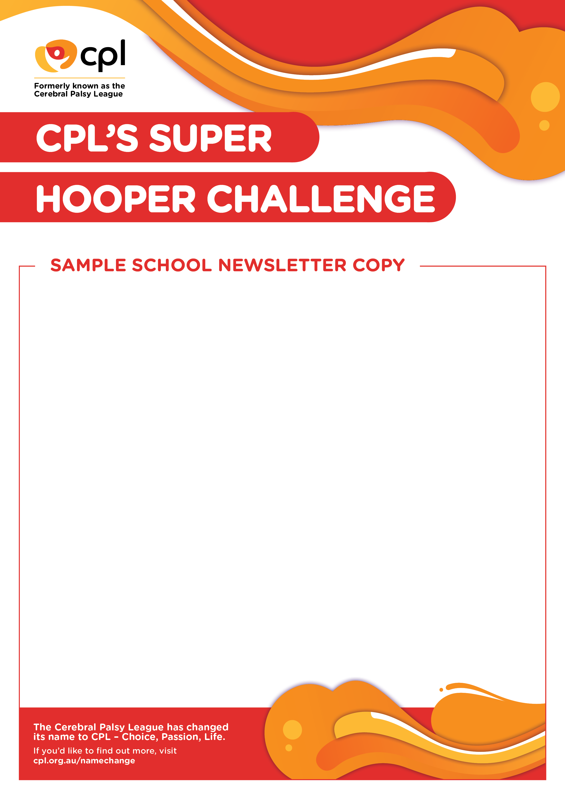

**Get ready to be a Super Hooper!**

Our school is taking part in CPL’s Super Hooper Challenge - a fantastic game for a good cause!

To play Super Hooper, students pay a gold coin donation which gives them three chances to shoot a ball into a hoop. They need to get at least one shot in to move on to the next round. There are four rounds, and barriers are added in each round to make it more difficult to shoot for the hoop. Students will need to use their opposite hand, wear an eye patch, or sit in a chair. It’s going to be a lot of fun!

Super Hooper is an initiative of CPL – Choice, Passion, Life, Queensland’s leading disability support provider. The idea is, by playing a game with barriers, students will learn about the challenges children with physical disabilities face on a daily basis. This is an important opportunity for us to raise awareness and funds for children living with disability. We want to be a school that is aware and inclusive of disability.

<SCHOOL NAME>’s Super Hooper Challenge will be held on <ENTER DATE> and this day will be a free dress day (TBC).

To learn more about CPL – Choice, Passion, Life, visit **www.cpl.org.au**

**SAMPLE FACEBOOK OR INSTAGRAM COPY**

Did you know we are taking part in CPL’s Super Hooper Challenge?

On <ENTER DATE>, our students will be testing their goal shooting skills while experiencing different barriers, like wearing an eye patch and sitting in a chair! By playing a game with barriers, our students will learn about the challenges children with physical disabilities may face every day.

Raising awareness and funds for children with disabilities? What a slam dunk!

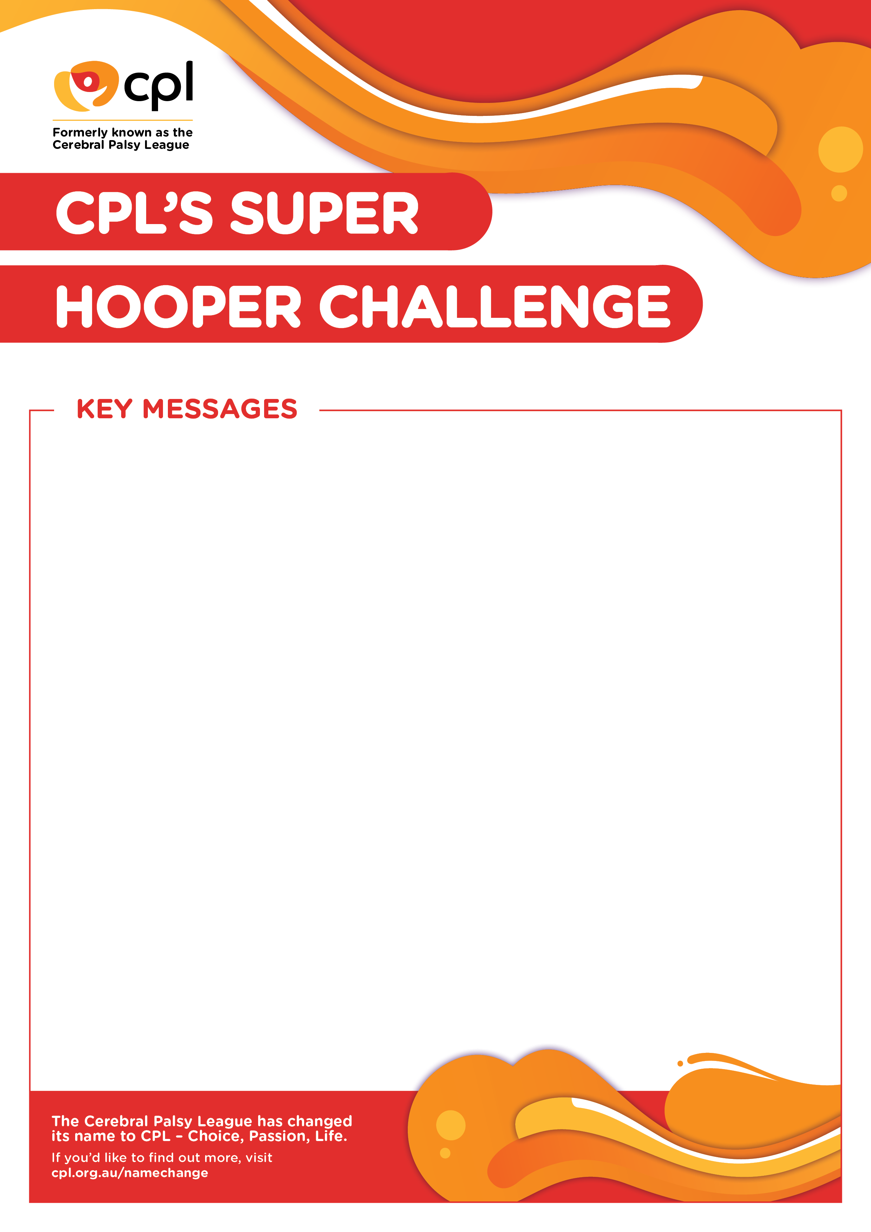

* CPL’s Super Hooper Challenge is an interactive and engaging way to create positive change in the lives of school children throughout Australia.
* To play CPL’s Super Hooper Challenge, students pay a gold coin donation which gives them 3 chances to shoot a ball into a hoop. If they shoot a hoop they will move on to the next round.
* There are four rounds in the Super Hooper Challenge. The more hoops the student scores, the harder the challenge. Barriers are added in each round to make it more difficult to shoot the ball into the hoop. The barriers include using the opposite hand, wearing an eye patch, and sitting in a chair.
* By playing a game with barriers, students will learn about the challenges children with physical disabilities can face.
* With an estimated 4.3 million Australians living with a disability, the Super Hooper Challenge is an opportunity to raise awareness, educate people and challenge their perceptions.
* Any school can participate in the Super Hooper Challenge! CPL has a toolkit available to guide each school in setting up the challenge.
* Funds raised are directed to CPL’sschool-based *Let’s Talk* program, which assists children with disabilities to communicate.
* To learn more about CPL – Choice, Passion, Life, visit **www.cpl.org.au**