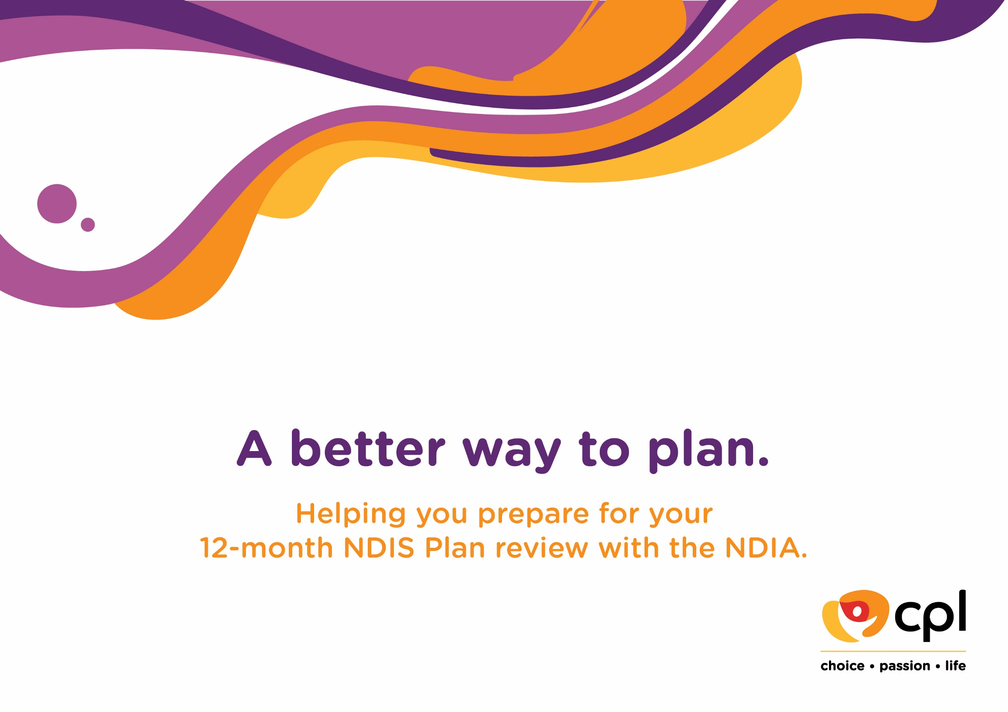

Name | Click or tap here to enter text.
Address | Click or tap here to enter text.
 | Click or tap here to enter text.

Contents

In this document, you will find templates, information and guidelines to help prepare for your next National Disability Insurance Scheme (NDIS) Plan review with
the National Disability Insurance Agency (NDIA).

Templates
Reviewing the goals on my current NDIS Plan 3
Reviewing the funding on my current NDIS Plan 4
Reviewing my current situation 5
My current situation – timetable 7
Support I need at home 8
Support I need in the community 9
Capacity building supports I need 10
Equipment maintenance I need 11
Capital supports I need 12
Goals for my next NDIS Plan 13
Notes 14

Glossary
Goal setting 15
Reasonable and necessary 16
Funding management 17
Support coordination 17
Consumables/Daily Adaptive Equipment 18
Assistive Technology 18
Meal preparation and delivery 18
Gardening, cleaning and home maintenance 19
Supported holidays 19
Transport 19
Supported Independent Living (SIL) 20
Speciallist Disability Accomodation (SDA) 21
Short Term Accomodation (STA) 21
Health supports 21
Meaningful engagement 22
School Leaver Employment Services (SLES) 23

Reviewing the goals on my current NDIS Plan
Looking at your current NDIS Plan, how do you think you have progressed towards your goals? Were there any things that got in your way?

Goals stated on my current Plan |  | Continue goal on next Plan? | How this goal was addressed
Goal 1 | Click or tap here to enter text. | Click or tap here to enter text. | Click or tap here to enter text.
Goal 2 | Click or tap here to enter text. | Click or tap here to enter text. | Click or tap here to enter text.
Goal 3 | Click or tap here to enter text. | Click or tap here to enter text. | Click or tap here to enter text.
Other goals | Click or tap here to enter text. | Click or tap here to enter text. | Click or tap here to enter text.
Other goals | Click or tap here to enter text. | Click or tap here to enter text. | Click or tap here to enter text.
As with anything to do with the NDIS, there are lots of variables and everyone’s circumstances are different. The NDIS will only fund any activity or equipment if they are considered 'reasonable and necessary' and are related to the goals in your NDIS plan. So make sure you can explain why you think how your supports relate to the 'reasonable and necessary' criteria and your plan.
Ask your therapists and care provider for evidence to support why you need the supports you want.

Reviewing the funding on my current NDIS Plan
 | Y/N | Explanation/detail
Did the funding on my Plan meet my needs? | Click or tap here to enter text. | Click or tap here to enter text.
Was there funding I didn’t/couldn’t spend in my Plan? If so, which category was it in? What stopped me from spending these funds? (For example, staffing issues, health issues, difficulty finding a service provider) | Click or tap here to enter text. | Click or tap here to enter text.
Other questions/concerns regarding current funds | Click or tap here to enter text. | Click or tap here to enter text.
Reviewing my current situation
Comments here relate to your current situation. Think about what might have changed for you since your last NDIS Plan. It is important to tell your
Planner if you are experiencing a decline and also to talk about things that may be changing for you in the near future.
Note: if you need to find different housing arrangements, or be considered for Supported Independent Living (SIL), please ensure you add this information into the table below next to “My housing arrangements”.
 | My situation is the same as last year | My situation has changed | What I need my Planner to know
My physical health  ☐ Complex Bowel Care  ☐ Enteral Feeding  ☐ Tracheostomy  ☐ Urinary Catheter  ☐ Ventilation  ☐ Subcutaneous Injection  ☐ Diabetes management  ☐ High Risk of Seizure  ☐ Pressure Care and Wound Management  ☐ Stoma Care | Click or tap here to enter text. | Click or tap here to enter text. | Click or tap here to enter text.
 | My situation is the same as last year | My situation has changed | What I need my Planner to know
My mental health | Click or tap here to enter text. | Click or tap here to enter text. | Click or tap here to enter text.
My housing arrangements | Click or tap here to enter text. | Click or tap here to enter text. | Click or tap here to enter text.
My informal supports (family or friends  who have been able to help me in the past) | Click or tap here to enter text. | Click or tap here to enter text. | Click or tap here to enter text.
My ability to organise my supports  or find new service providers | Click or tap here to enter text. | Click or tap here to enter text. | Click or tap here to enter text.
My ability to manage my funding | Click or tap here to enter text. | Click or tap here to enter text. | Click or tap here to enter text.
Other | Click or tap here to enter text. | Click or tap here to enter text. | Click or tap here to enter text.
My current situation - timetable
Fill out the table below with a schedule of what your current situation looks like. Consider what is working well for you, what you enjoy and what you
would like to change or improve. Also note whether there have been any changes to your activities or daily life.

 | 6am-9am | 9am-3pm | 3pm-6pm | 6pm-10pm | Overnight
Monday | Click or tap here to enter text. | Click or tap here to enter text. | Click or tap here to enter text. | Click or tap here to enter text. | Click or tap here to enter text.
Tuesday | Click or tap here to enter text. | Click or tap here to enter text. | Click or tap here to enter text. | Click or tap here to enter text. | Click or tap here to enter text.
Wednesday | Click or tap here to enter text. | Click or tap here to enter text. | Click or tap here to enter text. | Click or tap here to enter text. | Click or tap here to enter text.
Thursday | Click or tap here to enter text. | Click or tap here to enter text. | Click or tap here to enter text. | Click or tap here to enter text. | Click or tap here to enter text.
Friday | Click or tap here to enter text. | Click or tap here to enter text. | Click or tap here to enter text. | Click or tap here to enter text. | Click or tap here to enter text.
Saturday | Click or tap here to enter text. | Click or tap here to enter text. | Click or tap here to enter text. | Click or tap here to enter text. | Click or tap here to enter text.
Sunday | Click or tap here to enter text. | Click or tap here to enter text. | Click or tap here to enter text. | Click or tap here to enter text. | Click or tap here to enter text.

Support I need at home
Category of support | What support is needed for each category? (hours/days per week, equipment required)
Cleaning services (this might be weekly,  fortnightly, or a few times a year. Cleaning  services include cleaning of carpets,  windows, screens, ovens, ceiling fans, etc.  Think about the things you are unable to  do yourself) | Click or tap here to enter text.
Yard maintenance (mowing, tree  trimming, gutter cleaning, etc.) | Click or tap here to enter text.
Consumables (including continence products, mattress protectors, thickeners, tubing, etc.) | Click or tap here to enter text.
Transport (how many kms do I travel each  week) | Click or tap here to enter text.
Short-Term Accommodation (respite) | Click or tap here to enter text.
Other | Click or tap here to enter text.
Other | Click or tap here to enter text.

Support I need in the community
Type of support | Hours per day | Days per week | Weeks per year | Breakdown of  1:1, 1:2 and 1:3 hrs | Provider/location/purpose of the support
Centre-based programs  general | Click or tap here to enter text. | Click or tap here to enter text. | Click or tap here to enter text. | Click or tap here to enter text. | Click or tap here to enter text.
1:1 Community access | Click or tap here to enter text. | Click or tap here to enter text. | Click or tap here to enter text. | N/A | Click or tap here to enter text.
Group community access (Social Squad) | Click or tap here to enter text. | Click or tap here to enter text. | Click or tap here to enter text. | Click or tap here to enter text. | Click or tap here to enter text.
Screech Arts | Click or tap here to enter text. | Click or tap here to enter text. | Click or tap here to enter text. | Click or tap here to enter text. | Click or tap here to enter text.
Access Arts programs | Click or tap here to enter text. | Click or tap here to enter text. | Click or tap here to enter text. | Click or tap here to enter text. | Click or tap here to enter text.
Resource Fee | N/A | N/A | N/A | N/A | Click or tap here to enter text.
Other | Click or tap here to enter text. | Click or tap here to enter text. | Click or tap here to enter text. | Click or tap here to enter text. | Click or tap here to enter text.

Capacity building supports I need

Category of support | Purpose of this capacity building activity - how does this assist me to meet my goals? | Evidence provided?  (Y/N)
Improved daily living skills (physiotherapy, occupational therapy, speech therapy and social work) | Click or tap here to enter text. | Click or tap here to enter text.
Nursing supports (please see page 23 for a detailed list of what can be covered) | Click or tap here to enter text. | Click or tap here to enter text.
Improved health and wellbeing (Dietitian, Exercise Physiologist and Personal Trainer) | Click or tap here to enter text. | Click or tap here to enter text.
Improved relationships (behaviour support) | Click or tap here to enter text. | Click or tap here to enter text.
Support coordination | Click or tap here to enter text. | Click or tap here to enter text.
Plan management | Click or tap here to enter text. | Click or tap here to enter text.
Exploring housing options | Click or tap here to enter text. | Click or tap here to enter text.
Increased social and community participation | Click or tap here to enter text. | Click or tap here to enter text.
Program, resource or course fees | Click or tap here to enter text. | Click or tap here to enter text.
Finding and keeping a job (employment support) | Click or tap here to enter text. | Click or tap here to enter text.
School Leaver Employment Support (SLES) | Click or tap here to enter text. | Click or tap here to enter text.
Individual skills development | Click or tap here to enter text. | Click or tap here to enter text.
Skills development in a group setting | Click or tap here to enter text. | Click or tap here to enter text.
Other | Click or tap here to enter text. | Click or tap here to enter text.

Equipment maintenance I need
Equipment I currently have | Needs replacing? (Y/N) | Maintenance required (general/major repairs) | Evidence provided?  (Y/N)
Click or tap here to enter text. | Click or tap here to enter text. | Click or tap here to enter text. | Click or tap here to enter text.
Click or tap here to enter text. | Click or tap here to enter text. | Click or tap here to enter text. | Click or tap here to enter text.
Click or tap here to enter text. | Click or tap here to enter text. | Click or tap here to enter text. | Click or tap here to enter text.
Click or tap here to enter text. | Click or tap here to enter text. | Click or tap here to enter text. | Click or tap here to enter text.
Click or tap here to enter text. | Click or tap here to enter text. | Click or tap here to enter text. | Click or tap here to enter text.
Click or tap here to enter text. | Click or tap here to enter text. | Click or tap here to enter text. | Click or tap here to enter text.
Click or tap here to enter text. | Click or tap here to enter text. | Click or tap here to enter text. | Click or tap here to enter text.
Click or tap here to enter text. | Click or tap here to enter text. | Click or tap here to enter text. | Click or tap here to enter text.
Is there any low-cost equipment that would help? | Click or tap here to enter text.

Capital supports I need

 | What is needed? | Evidence provided? (Y/N)
☐ New equipment | Click or tap here to enter text. | Click or tap here to enter text.
☐ House modifications | Click or tap here to enter text. | Click or tap here to enter text.
☐ Car modifications | Click or tap here to enter text. | Click or tap here to enter text.

Helpful tip:
If you require a specialised or modified vehicle because of your disability, the NDIS may be able to help pay for modifications. The NDIS won’t pay for the vehicle, but may cover modifications required to get in and out of your vehicle, or to operate it. The NDIS will only provide funding for a vehicle modification when it’s seen as offering value for money.

Goals for my next Plan
The goals on your NDIS Plan will be linked to the funding you receive. Write your goals in order of what is most important to you.
Ask yourself:
- Are there any new goals I would like in my next NDIS Plan?
- Which things are most important to me now?
- Which things would I most like to change?
- What would I like to do with less help from others?
- Are there new things I would like to try?
If you need to find different housing arrangements, want to be considered for Supported Independent Living (SIL), or need to live in Specialist Disability Accommodation (SDA), please make that your first goal.

Goal |  | What do I need to do to achieve this goal: | Equipment/aids/devices I need to help me address this goal
Goal 1 | Click or tap here to enter text. | Click or tap here to enter text. | Click or tap here to enter text.
Goal 2 | Click or tap here to enter text. | Click or tap here to enter text. | Click or tap here to enter text.
Other goal | Click or tap here to enter text. | Click or tap here to enter text. | Click or tap here to enter text.

Notes

Click or tap here to enter text.

GLOSSARY
Goal setting
Goals are the foundation of your NDIS Plan. Think about what you want your life to look like in three years and what you might need in order to get to that point. The NDIS will fund “reasonable and necessary” supports for a person with a disability to reach their goals. Being clear about your goals from the start ensures your NDIS Plan includes the supports that are vital to achieving your objectives. Your goals might be big and long-term, others might be small and short-term. Just remember, your goals should focus on an outcome rather than the services needed to achieve that outcome.
Easy steps to goal setting:
- Identify what is important to you. What would you like to achieve? This might be:
- something you are dreaming about, like finding a job or going on holiday with support
- your current life activities, for example expanding your social network or improving your living situation
- everyday activities, such as being able to get out of bed, or improving communication skills
- maintaining your roles and responsibilities of being a parent, active family member or friend.

- What are the barriers stopping you from achieving these goals? For example, does your mobility, equipment, transport, or lack of support prevent you from meeting these goals? Could there be other things which limit your ability to achieve them? What could these be?
Make sure you keep it simple. Your supports need to relate to your goals; keep your goals broad so you can still make changes throughout the course of your Plan.
Examples of goals:
- I want to improve my communication at home and in the community so I can be as independent as possible.
- I would like increase my participation in community and social activities so I can make new connections with others, including exploring volunteer opportunities.
- I want to explore different housing options for me to live independently in the future.
- I want to increase my independence and life skills away from my family.
- I want to increase my skills so I can get a job.
Reasonable and necessary
The NDIS uses the term “reasonable and necessary” fairly often. It is the basis of which supports will be included in your NDIS Plan. For a support
to be “reasonable and necessary”, it must:
- help you achieve the goals and aspirations you identified in your NDIS Plan
- get you more connected to your community, either socially or economically
- represent tangible value for money, particularly if it’s priced above the NDIS price guide
- use established, science-based methods and be likely to provide a real benefit
- not serve as a stand-in for what should reasonably be provided by other parties, such as family members, carers or the community
- not fund a support that could be funded by another more appropriate method, such as another government body.
Put simply: for something to be considered “reasonable and necessary” it must be directly related to your disability and represent value for money.
The below diagram can be handy for deciding whether a support is “reasonable and necessary”.
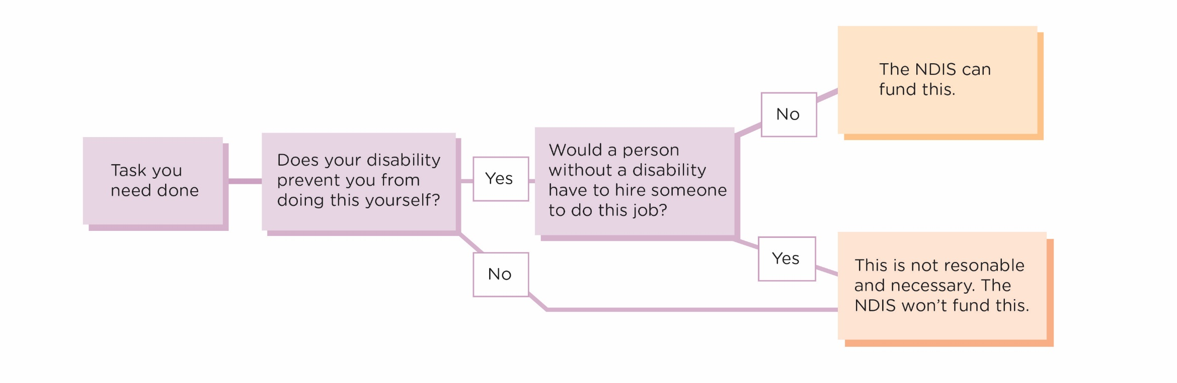
Funding management
There are three different types of funding management:
Self-managed
When choosing to self-manage, you will receive funding from the NDIA so you can select and pay for the services which will help you meet your goals. You are not limited to using only NDIS registered providers and not tied to the NDIS price guide. You need to have the capacity and time to engage with providers, pay invoices and be able to keep records and receipts in case you are audited. You will need to set up a separate bank account for this. It’s important the NDIS has your current bank account details on file, or else you might not receive your funds, so head to the NDIS myplace portal to view and amend your bank details.

Plan-managed
The NDIS will pay your Plan Manager, who will directly pay for all the supports you have asked them to manage. You do not have to use NDIS
registered providers. The Plan Manager will pay your invoices and send you monthly statements to help track your spending. Plan Managers follow the
NDIS price guide.

NDIA-managed
When the NDIA manages your Plan, you will need to choose registered NDIS providers. The NDIA will directly pay your providers for you.

You don't need to choose only one type of funding management for your whole Plan. For example, you may want to NDIA-manage your core funding so you can use agency Support Workers, but you may want to self-manage your capacity building budget so you can choose therapists who may not be registered providers. Please note, there are some services that can only be NDIA-managed, like behavioural supports.

Support coordination
A Support Coordinator helps you implement your NDIS Plan and understand your funding and how you can use it. They can also:
- help you to find services available to you, including mainstream, community, informal and provider options
- assist you to choose your preferred support options and providers
- develop service agreements
- arrange any assessments you require
- help to budget your Plan
- work with other people in your support network (e.g. therapists, service providers, family members, mainstream supports)
- assist you to prepare for your next NDIS Plan review meeting.

Consumables/Daily Adaptive Equipment
Consumables/Daily Adaptive Equipment includes simple, low-cost equipment which can be bought off the shelf without any need for customisation. For example, large print labels, walkers and rollators. Usually the maximum cost for this equipment is $1500. The NDIS generally will not fund tablets or smartphones, as they are considered everyday items. While the devices themselves might not be funded, the apps you use on them can be, providing they relate to your support needs or the goals in your NDIS Plan.
Smartwatches often come loaded with features which can assist NDIS participants, like the new Apple Watch’s ability to detect falls. The NDIS considers smartwatches to be mainstream technology and generally won't fund them. However, if a feature tied to your support needs is built in to the watch itself and not available as an app, the NDIS might fund it. The NDIS is unlikely to fund any premium tech products if a cheaper alternative will do a similar job. As each situation is different, make sure you clarify clearly why you need a certain device or app and tie everything back to the goals and needs described in your Plan.

Assistive Technology
If you require a more complex Assistive Technology product which needs to come from a specialist disability supplier, then you may be able to get funding in this category. You would need an occupational therapy assessment to confirm you need the product and to ensure its suitability. If you’re requesting to have Assistive Technology included in your Plan, be sure to ask for “Improved Daily Living” funding, as you’ll need an Occupational Therapist (or other specialised therapist) to assess your need and get quotes for your equipment. Given the NDIS can take a long time to approve quotes, you can request funding to rent equipment so you’re never without. You can also get a repair allowance to maintain your equipment, so ask for this in your planning meeting. Even if you have Plan Management, the funding for Assistive Technology is, in most cases, managed by the NDIS and therefore requires the use of registered providers.

Meal preparation and delivery
The NDIS may provide funding for the preparation and delivery of meals. If your disability prevents you from shopping or preparing meals yourself, the NDIS can deem it as being “reasonable and necessary” and fund it. The NDIS might also fund meal preparation and delivery if your primary carer only has the time and opportunity to provide you with the essential supports and not with shopping or cooking. However, if you or your primary carer are
able to shop and cook for yourself, the NDIS won’t cover it. The NDIS does not fund the actual cost of the food/meal. If this is an area you
need help in, make sure you explain this to your Planner.

Gardening, cleaning and home maintenance
The NDIS can provide funding for support with gardening, cleaning and home maintenance. It’s important to point out it will only fund these supports if they’re “reasonable and necessary” and directly related to your disability. If you’re unable to perform a task – like vacuuming or mowing the lawn – because your disability makes it impossible, then the NDIS may fund it. Ensure you explain your situation to your Planner.

Supported holidays
The NDIS can fund the support staff you need while you are on holidays. If going on holidays is one of your goals, explain this to your Planner and ask them to include extra funding to cover the staff you will need on holidays. If you currently live in a SIL house, make sure to still request funding for a holiday from your core supports.
It’s important to note the NDIS won’t fund holiday expenses such as travel costs, plane tickets, accommodation, food, or entertainment.

Transport
If your disability means you can’t use public transport by yourself, you might be eligible to have “Transport Allowance” funding in your NDIS Plan. These funds can then be used to help pay for taxis, rideshares, community transport and other transport methods. If you receive “Transport Allowance” funding, your funds will most likely be paid directly into your bank account on a fortnightly basis to help contribute to your travel expenses. You will need to self-manage this particular category.
From 1 March 2020 you will be able to use your core support funding to pay some of your transport costs. These are in addition to your Support Worker’s time and are charged by the kilometre. You will just need to let the NDIS know how many kilometres you travel with your service provider so this can be funded in your core supports.

If your disability makes it hard for you to get around but you would like to learn to overcome these challenges, you might be eligible
for additional funding under “Improved Daily Living”. This funding can be used for things like public transport training or additional driving
lessons, designed to build your independence, skills and confidence.

Supported Independent Living
Supported Independent Living (SIL) is assistance from paid Support Workers at home for people who require access to 24/7 support. A common arrangement is two or three people sharing a home, with staff sleeping over at night. In SIL, Support Workers are always available to supervise or assist with daily tasks like personal care, household, decision making, and domestic duties. If you think you would like to move into this type of independent living, the first step is to tell your Planner this is one of your goals. The NDIS can include this in your next Plan and provide assistance for you to achieve this goal.
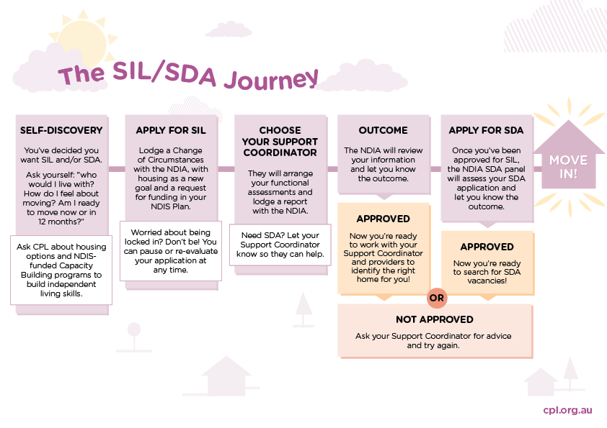

Specialist Disability Accommodation
Specialist Disability Accommodation (SDA) refers to housing for participants who require specialist solutions to assist with the delivery of their
supports. SDA caters for significant functional impairment or very high support needs. SDA does not refer to the support services themselves, but
the home in which these services are delivered. The NDIA pays SDA funding directly to the Housing Provider. SDA funding is for the ongoing management, maintenance and lifecycle planning of the property. If you think you need to live in SDA, the first step is to tell your Planner this is one of your goals.

Short-Term Accommodation
The NDIA recognises that looking after family, carers and support networks is an important part of the overall care of a person with a disability. Short-Term Accommodation (STA), or respite care as some people know it, can be a valuable part of this bigger picture. The NDIS can fund STA for the person with the disability.

Health supports
The NDIA will now pay for disability-related health supports where the supports are a regular part of your daily life and result from your disability. Think about the health supports you currently access or need to access for this section. These can include:

Dysphagia supports | Development of oral eating and drinking care plans  Swallowing therapy associated with dysphagia provided by an Allied Health professional
Diabetic management supports | Development of a diabetic management plan  Daily maintenance and care associated with a diabetic management plan (if the participant is unable to self-manage due to their disability)
Continence supports | Catheter changes, cleaning of catheters, consumables, assessments, plans and reviews
Wound and pressure care supports | Wound care consumables (e.g. dressings), Lymphedema machines, Lymphedema garments
Respiratory supports | Tracheostomy changes, Tracheostomy clinical management, Tracheostomy equipment and consumables, Constant Positive Airway Pressure (CPAP) machine and consumables, Bi-level Positive Airway Pressure (BiPAP) machine and consumables, air humidifier, portable suction machine, cough assist machine, ventilator
Nutrition supports | Percutaneous Endoscopic Gastrostomy (PEG) and HEN equipment (or similar) and consumables excluding Food formula, thickeners and nutritional supplements, PEG stoma changes, dietetic consultations, development of nutritional meal plans, development of meal time management plans
Podiatry and foot care supports | Podiatry diagnosis, assessment and development of a podiatry care plan
Epilepsy supports | Epilepsy monitoring through assistive technology

Meaningful engagement
Meaningful engagement can involve:
- Using a Disability Employment Service (DES) to gain employment
- Participating in supported employment through an Australian Disability Enterprise
- Undertaking further education through a TAFE or university
- Volunteering
- Attending community events.
One of the underlying principles of the NDIS is to facilitate social and economic participation for people living with a disability. This does not mean the NDIS is going to make you look for a job if it is not one of your goals. It is also not there to make you participate in social activities you are not interested in. The funded supports are there for you to be able to access your community, spend your money in the way you choose to, do the activities you want, and participate in your community in a way that suits you best. You have the choice and the control.

School Leaver Employment Supports
School Leaver Employment Supports (SLES) is available to Year 12 school leavers who are eligible for the NDIS. SLES helps young people prepare for and take part in employment. Through SLES, school leavers will receive supports for up to two years which are focused on improving employment opportunities by getting them job-ready. The supports provided are tailored to meet individual employment goals. They can include work experience and skills development in areas such as time management, travelling, money handling, taking instructions and understanding expectations. Young people will also be linked to further ongoing supports through a Disability Employment Service (DES) provider.

